Homework 5

1. Processes with one CPU
   1. Gantt Charts: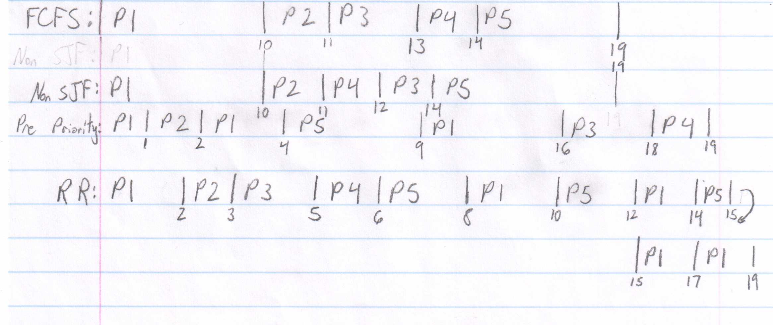
   2. Turnaround time
      1. FCFS:
         1. 10 ms
         2. 10 ms
         3. 11 ms
         4. 11 ms
         5. 15 ms
      2. Non-preemptive SJF:
         1. 10 ms
         2. 10 ms
         3. 12 ms
         4. 9 ms
         5. 15 ms
      3. Preemptive Priority:
         1. 15 ms
         2. 1 ms
         3. 16 ms
         4. 16 ms
         5. 5 ms
      4. Round Robin:
         1. 19 ms
         2. 2 ms
         3. 3 ms
         4. 3 ms
         5. 11 ms
   3. Average waiting time
      1. FCFS: (0 + 9 + 9 + 10 + 10) / 5 = 38 ms
      2. Non-preemptive SJF: (0 + 9 + 10 + 8 + 10) / 5 = 37 ms
      3. Preemptive Priority: (7 + 0 + 14 + 15 + 0) / 5 = 36 ms
      4. Round Robin: (9 + 1 + 1 + 2 + 6) / 5 = 19 ms
2. Task Scheduler
   1. CPU Utilization will be 1/1.1 = 91% because each task will only use up 1ms of CPU time, and the scheduler will use .1ms of time, bringing the time total to 1.1ms where only 1ms is actually being used by the CPU.
   2. CPU Utilization will be 20/21.1 = 94% because each I/O task will take 1.1ms, giving us 10\*1.1 = 11ms and the CPU task will take 10 + .1 = 10.1ms total, since the CPU isn’t being preempted by the I/O tasks like in part a.